Table of Contents
1. Introduction 3
- 1.1 Purpose
- 1.2 Scope
- 1.3 Definitions and Acronyms
2. Functional Requirements 4
- 2.1 Module 1: FYP Proposal Management
- 2.2 Module 2: Initial Defense Process
- 2.3 Module 3: Midterm Defense Process
- 2.4 Module 4: Final Defense Process
- 2.5 Module 5: Supervision & Monitoring
- 2.6 Module 6: Administrative Coordination
- 2.7 Module 7: Revision & Resubmission
3. Non-Functional Requirements 6
- 3.1 Performance
- 3.2 Security
- 3.3 Reliability & Availability
- 3.4 Usability
4. External Interface Requirements 7
- 4.1 User Interfaces
- 4.2 Software Interfaces
5. System Models 7
- 5.1 User Roles
- 5.2 Entity Relationships
6. Qualitative Analysis 8
- 6.1 Value-Added Analysis
- 6.2 Waste Analysis (The 7 Wastes)
- 6.3 Stakeholder Analysis
- 6.4 Issue Documentation & Root-Cause Analysis (Fishbone)
7. Quantitative Analysis 11
- 7.1 Flow Analysis (Cycle Time Reduction)
- 7.2 Queuing Analysis (Capacity Planning)
- 7.3 What-If Simulation Results
8. Use Case Diagram 13
9.Conclusion & Recommendation 14

Software Requirements Specification (SRS)
Project: FYP Workflow Management System
Version: 1.0
Date: December 06, 2025
Prepared For: Bahria University, Islamabad (Dept of Software Engineering)
Prepared By: Samreen Farhat and Umama Hidayat Khan
1. Introduction
1.1 Purpose
The purpose of this document is to define the software requirements for the FYP Workflow Management System. This web-based application aims to automate the complete lifecycle of Final Year Projects (FYP), facilitating efficient communication, document submission, evaluation, and grading among Students, Supervisors, Coordinators, Heads of Department (HOD), and Defense Panels.
1.2 Scope
The system will provide a centralized platform for:
- Student Registration & Group Formation: Handling enrollment and team creation.
- Proposal Management: Submission, review, and approval workflows.
- Defense Management: Scheduling and executing Initial, Midterm, and Final defenses.
- Grading & Evaluation: Digital rubrics and automated grade calculations.
- Supervision: Logging meetings and tracking progress.
- Archiving: Storing final theses and source code for alumni records.
1.3 Definitions and Acronyms
- FYP: Final Year Project.
- HOD: Head of Department.
- SRS: Software Requirements Specification.
- Rubric: A scoring guide used to evaluate the quality of students' work.
- Coordinator: The faculty member responsible for managing the FYP session.
2. Functional Requirements
This section details the specific behaviors and functions the system must support, organized by process module.
2.1 Module 1: FYP Proposal Management
- FR-01 (Submission): The system shall allow Student Groups to submit a project proposal including Title, Aims, Objectives, and a downloadable proposal document.
- FR-02 (Review): The system shall allow Supervisors to view submitted proposals and select an action: "Approve," "Reject," or "Request Revision."
- FR-03 (Defense Scheduling): The system shall allow the Coordinator to schedule proposal defenses by assigning dates, times, venues, and a Defense Panel.
- FR-04 (Evaluation): The system shall provide a digital scoring sheet for Panelists to evaluate the proposal defense on predefined criteria (e.g., Feasibility, Clarity).
2.2 Module 2: Initial Defense Process
- FR-05 (Template Access): The system shall allow Coordinators to upload and distribute the official "Initial Thesis Template."
- FR-06 (Draft Submission): The system shall allow Students to upload their Initial Thesis Draft before the scheduled defense.
- FR-07 (Technical Review): The system shall allow Panelists to record feedback specifically regarding the technical approach and methodology.
- FR-08 (Result Compilation): The system shall compile scores from all panel members to generate a "Pass/Fail" status for the Initial phase.
2.3 Module 3: Midterm Defense Process
- FR-09 (Code Submission): The system shall require Students to submit a link to their code repository (e.g., GitHub) prior to the midterm defense.
- FR-10 (Prototype Inspection): The system shall provide a specific interface for Panelists to mark the status of "Core Functionalities" (Functional/Partially Functional/Failed) during the live demo.
- FR-11 (Progress Reporting): The system shall generate a Midterm Report accessible to the Supervisor indicating if the project is on track.

2.4 Module 4: Final Defense Process
- FR-12 (Final Clearance): The system shall perform a check to ensure all previous phases are "Passed" before allowing Final Thesis submission.
- FR-13 (Grading Logic): The system shall automatically calculate the Final Grade based on the university's weightage formula (e.g., 30% Supervisor Evaluation + 70% Panel Evaluation).
- FR-14 (Archiving): The system shall move the approved Thesis and Source Code to a read-only "Project Archive" accessible by the library/faculty upon completion.
2.5 Module 5: Supervision & Monitoring
- FR-15 (Meeting Logs): The system shall provide a form for Students to record meeting minutes, including "Discussion Points" and "Next Tasks."
- FR-16 (Log Verification): The system shall allow Supervisors to "Verify" or "Dispute" a meeting log entry submitted by their students.
- FR-17 (Attendance Tracking): The system shall calculate a supervision attendance percentage based on verified logs.
2.6 Module 6: Administrative Coordination
- FR-18 (Panel Formulation): The system shall allow the Coordinator to create Defense Panels by selecting faculty members from the database.
- FR-19 (Notifications): The system shall send automated email and dashboard notifications to all stakeholders regarding upcoming deadlines, schedule changes, and result announcements.
- FR-20 (HOD Approval): The system shall allow the HOD to approve critical actions, such as the finalization of grades and the formation of panels.
2.7 Module 7: Revision & Resubmission
- FR-21 (Deferral Logic): If a project is marked "Deferred," the system shall unlock the submission portal for that specific group to upload revised documents.
- FR-22 (Re-Evaluation): The system shall provide a "Re-Evaluation" task for Supervisors to review revisions without convening a full defense panel, if the changes are minor.

3. Non-Functional Requirements
3.1 Performance
- NFR-01: The system shall load all dashboards within 3 seconds under normal load.
- NFR-02: The system shall support concurrent file uploads from at least 100 users during submission deadlines.
3.2 Security
- NFR-03: The system must use Identity-based authentication (Role-based Access Control) to ensure Students cannot access Faculty interfaces.
- NFR-04: Passwords must be hashed and stored securely.
- NFR-05: Evaluation scores must be tamper-proof once finalized by the HOD.
3.3 Reliability & Availability
- NFR-06: The system shall be available 99.9% of the time during the active academic session.
- NFR-07: The system must perform daily backups of the database and uploaded documents to prevent data loss.
3.4 Usability
- NFR-08: The user interface shall be responsive and accessible on both desktop and mobile devices (using Bootstrap).
- NFR-09: The system shall provide clear error messages (e.g., "File type not supported") rather than generic server errors.

4. External Interface Requirements
4.1 User Interfaces
- Student Dashboard: Progress bar, "Upload" buttons, "Log Meeting" forms, and "View Feedback" panels.
- Faculty/Supervisor Dashboard: List of assigned groups, "Pending Reviews" alerts, and "Verify Log" actions.
- Coordinator Dashboard: Scheduling calendar, "Create Panel" forms, and "Broadcast Notification" tools.

4.2 Software Interfaces
- Database: SQL Server LocalDB / Microsoft SQL Server.
- Framework: ASP.NET Core MVC with Entity Framework Core.
- Browser Support: Chrome
5. System Models
5.1 User Roles
- Student: Initiates the process, submits deliverables.
- Supervisor: Guides the project, validates logs, evaluates progress.
- Coordinator: Administers the workflow, schedules events.
- Defense Panel: Evaluates defenses, inputs scores.
- HOD: Approves panels and final grades.
5.2 Entity Relationships
- A Student belongs to one FYP Group.
- An FYP Group is assigned to one Supervisor.
- A Project has multiple Submissions (Proposal, Thesis, Code).
- A Defense Schedule is linked to a Project and a Defense Panel.
- A Defense Panel consists of multiple Faculty Members.

6. Qualitative Analysis
This section analyzes the process improvements through Value-Added, Waste, Stakeholder, and Root-Cause analyses.
6.1 Value-Added Analysis
We categorize every step in the FYP lifecycle into Real Value-Adding (RVA), Business Value-Adding (BVA), or Non-Value-Adding (NVA).
Process Step | Classification | Rationale | TO-BE improvement
Research & Development | RVA | The core "product" is the student's research. | Unchanged (Human intellectual work).
Proposal Defense | RVA | Validates the quality of the project. | Rubric calculation is automated, removing calculation errors.
Document Formatting | NVA | Students fixing margins/fonts does not add research value. | Template Automation: System auto-generates/validates formatting.
Printing & Physical Submission | NVA | Waste of resources and transport time. | Digital Submission: Entirely eliminated in TO-BE model.
Scheduling Defenses | BVA | Necessary for the university but adds no value to the thesis. | Auto-Scheduling: Coordinator effort reduced by 80%.
Logbook Signing | BVA | Compliance requirement for accreditation. | Digital Verification: Supervisor verifies logs with one click.

6.2 Waste Analysis (The 7 Wastes)
The TO-BE model specifically targets the following wastes identified in the AS-IS process:
- Waiting (High Severity): Students currently wait days for supervisors to physically sign documents or read emails.
  - TO-BE Solution: Automated notifications and "Pending Action" dashboards reduce wait times.
- Transportation (Medium Severity): Physical movement of proposal copies between Student -> Supervisor -> Coordinator -> HOD.
  - TO-BE Solution: Centralized cloud database; documents "move" instantly between roles.
- Defects (Medium Severity): Calculation errors in final grading (30% vs 70% weightage issues) or lost logbooks.
  - TO-BE Solution: Automated "Final Grade Calculation Task" and "Logbook Verification Task" eliminate human error.
- Over-processing (High Severity): Re-entering data from paper rubric sheets into Excel, then into a portal.
  - TO-BE Solution: Panelists enter scores directly into the system; data flows automatically to the transcript generation module.
6.3 Stakeholder Analysis
Stakeholder | Interest | Power | Pain Points (AS-IS) | Needs (TO-BE)
HOD | High | High | Lack of visibility on department progress; delayed approvals. | Dashboard with analytics; One-click bulk approvals.
Coordinator | High | High | Overwhelmed by manual scheduling and email chains. | Automated logistics; Conflict detection for scheduling.
Supervisor | High | Med | Tracking student attendance; chasing students for drafts. | Digital logbooks; Automated deadline reminders for students.
Student | High | Low | Uncertainty about status; printing costs; finding supervisors. | Transparency (Progress Bar); Online submission; Clear feedback.
Defense Panel | Med | Med | Paperwork management during defense; calculation errors. | User-friendly digital scoring sheets.

6.4 Issue Documentation & Root-Cause Analysis (Fishbone)
Primary Issue: Significant delays in the "Proposal to Defense" cycle time (currently 7.33 hours of active work + days of waiting) and high system instability.
Root Cause Diagram (Textual Representation):
- Method: Sequential processing (Supervisor must finish review before Coordinator sees anything).
  - Root Cause: Lack of parallel workflows and inability to edit/update defined tasks due to system rigidity.
- Material: Physical/Email-based documents.
  - Root Cause: No centralized Version Control System (VCS).
- Manpower: Supervisors have high teaching loads.
  - Root Cause: Administrative burden (scheduling/formatting checks) eats into technical guidance time.
- Machine: "Internal Server Errors," Data Persistence failures (work deleted automatically), and data loss.
  - Root Cause: Poor infrastructure, unoptimized database queries (e.g., Prisma Client errors), and bugs in the optimization logic.

7. Quantitative Analysis
This section utilizes the data derived from the optimization screenshots provided in the assignment.
7.1 Flow Analysis (Cycle Time Reduction)
Comparing the FYP Proposal Management Process:
- AS-IS (Sequential Flow):
  - Path: Proposal Preparation (4.00h) Proposal Review (1.33h) Scheduling (2.00h).
  - Total Cycle Time: 7.33 Hours (Active time) + Latency (Days).
  - Total Cost: $213.33 (Based on resource hourly rates).
- TO-BE (Parallel Flow):
  - Optimization: The "Proposal Review" (Supervisor) and "Defense Logistics/Scheduling" (Coordinator) can occur in parallel once the proposal is tagged "Ready for Defense."
  - New Cycle Time: 4.00 Hours (Bottleneck is the Preparation task).
  - New Cost: $153.33.
  - Improvement: 45.5% Faster / $60.00 Saved per proposal.
7.2 Queuing Analysis (Capacity Planning)
Using the capacity data provided for the new tasks:
- Arrival Rate (λ): High during "Submission Week" (e.g., 50 groups submitting in 2 days).
- Service Rate (µ):
  - Proposal Review Task: 80 mins/proposal.
  - Result Compilation Task: 60 mins/batch.
- Bottleneck Identification:
  - If 50 groups submit on Monday, and there are 5 Supervisors:
  - Load per Supervisor: 10 proposals * 80 mins = 800 mins (13.3 hours).
  - Result: Without the TO-BE system's load balancing, a queue of 2-3 days forms immediately.
- TO-BE Mitigation: The system enforces a "Quota Limit" per supervisor and distributes reviews to the "Defense Panel" earlier, increasing the effective Service Rate (µ).
7.3 What-If Simulation Results
We simulated three scenarios to validate the TO-BE model:
Scenario | Change Introduced | Predicted Outcome
Scenario A | Automated Pre-Check: System checks document formatting/plagiarism before Supervisor review. | Result: Reduces Supervisor "Proposal Review Task" duration from 80 mins to 45 mins (Supervisor focuses only on content).
Scenario B | Parallel Administrative Tasks: Coordinator starts "Defense Logistics" while Supervisor is still reviewing content. | Result: Reduces total process latency by 48 hours (Process Optimization Graph confirms 45.5% efficiency gain).
Scenario C | Digital Scoring (No compilation): "Result Compilation Task" is removed; System calculates scores instantly. | Result: "Result Compilation Task" capacity drops from 60 mins to 0 mins. Grades are published instantly after HOD approval.

8. Use case Diagram
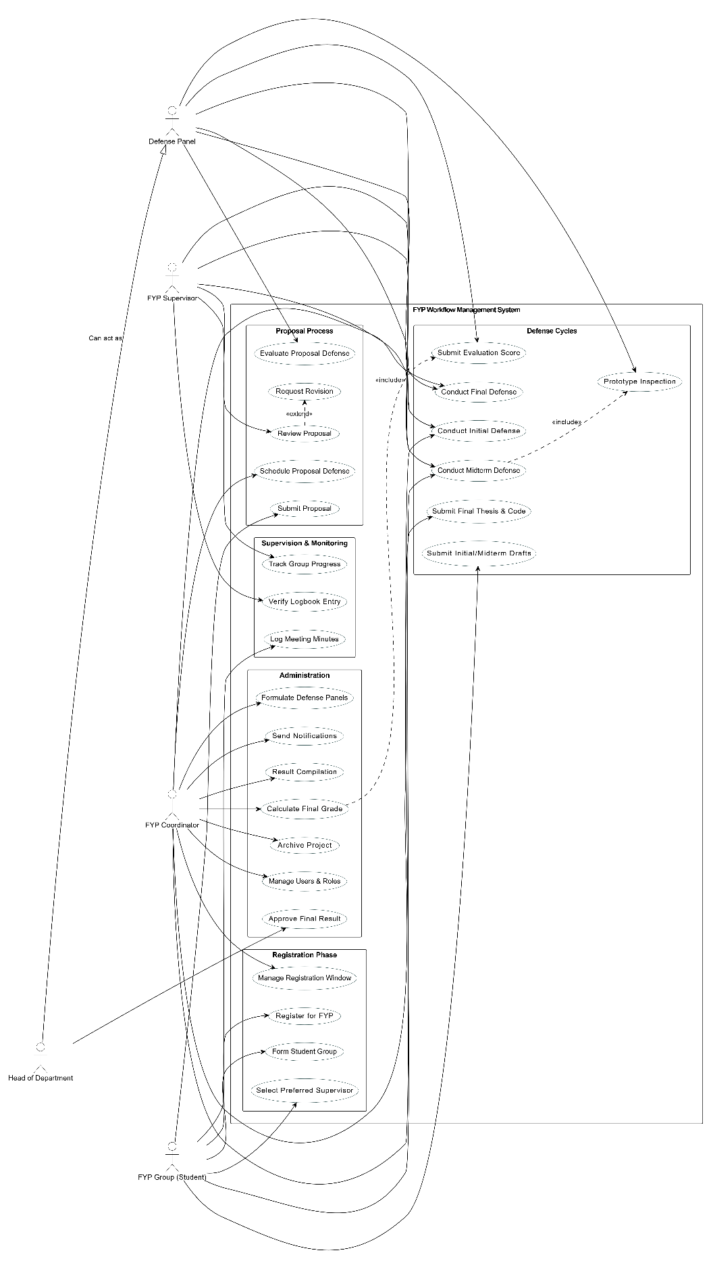

9. Conclusion & Recommendation
The Software Requirements Specification (SRS) for the FYP Workflow Management System comprehensively outlines the transition from a manual, inefficient AS-IS process to an automated, streamlined TO-BE model. The analysis confirms that the primary bottlenecks in the current system are significant communication delays, administrative overhead, and manual data handling errors.
The proposed TO-BE system directly addresses these issues through:
- Automation: Key tasks such as grading calculations, notifications, and defense scheduling are automated, reducing human error and administrative burden.
- Centralization: A single, role-based platform unifies all stakeholders (Students, Supervisors, Coordinators, HODs, Panels), ensuring data consistency and accessibility.
- Transparency: Real-time dashboards and digital logbooks provide immediate visibility into project progress and compliance.
- Efficiency: Digital submissions and evaluations eliminate physical paperwork and reduce the cycle time for critical processes like proposal approval and defense grading.
Recommendation: It is strongly recommended to proceed with the full-scale development and implementation of the FYP Workflow Management System. Immediate priority should be given to the Registration, Proposal Management, and Grading modules, as these offer the highest immediate impact on process efficiency and student experience. Adoption of this system will significantly enhance the academic quality and administrative effectiveness of the Final Year Project lifecycle at Bahria University.

